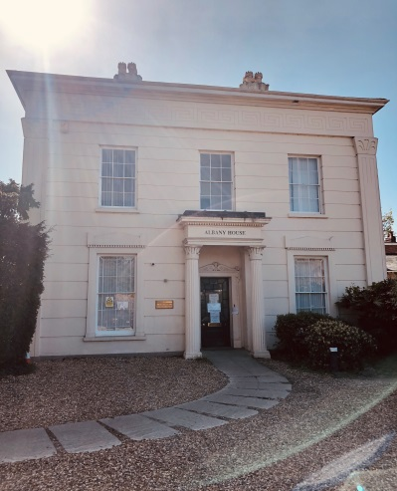**GP (Locum cover)**

**Albany House Surgery, Worcester**

**4 Albany Terrace, Worcester. WR1 3DU**

**Location:**  4 Albany Terrace, Worcester, WR1 3DU  
**Contract:**  3 months (covering salaried GP leave)  
**Sessions:**  4–6 clinical sessions per week, negotiable  
**Start date:**  September 2025  
**Salary:**  Dependent on experience

Albany House Surgery is a friendly, supportive, and high-performing practice based in a beautiful Grade II listed building in the heart of Worcester. We care for a diverse patient population of just over 7,000 people and pride ourselves on delivering excellent, compassionate healthcare.

We are looking for a conscientious and approachable GP to join our enthusiastic and dynamic team for a three-month period while one of our salaried doctors is on leave. You will work closely with our experienced clinicians, contributing to the smooth running of the practice and providing high-quality care to our patients.

Our team includes three GP partners, three salaried doctors, a training ANP, a practice nurse and three HCAs, supported by an excellent management and administrative team. As a training practice, we value ongoing professional development and encourage open collaboration. Regular clinical meetings provide a forum to share ideas, discuss cases and support each other. We also take part in clinical research and deliver a range of enhanced services, including minor surgery, insulin initiation and family planning clinics. The practice consistently achieves maximum QOF points and has been rated “Good” by the CQC.

We believe that a warm, welcoming atmosphere and a good sense of humour are essential to how we work. If you share our passion for great patient care and enjoy being part of a supportive team, we would be delighted to hear from you.

*For further information or to apply, please contact Dr R Hamilton on 01905 26086 or email albany.managers@nhs.net.*